**Question#1**

**Code :**

#include<iostream>

using namespace std;

bool checkInverse(int arr1[5][5], int arr2[5][5], int rows, int coloums) {

int arr3[5][5] = { {0} };

for (int i = 0; i < rows; i++) {

for (int j = 0; j < rows; j++) {

for (int k = 0; k < coloums; k++) {

arr3[i][j] = arr3[i][j] + arr1[i][k] * arr2[k][j];

}

}

}

int flag = 0;

for (int i = 0; i < rows; i++) {

for (int j = 0; j < coloums; j++) {

if (i == j && arr3[i][j] != 1 || i != j && arr3[i][j] != 0) {

flag = 0;

}

else {

flag = 1;

}

}

}

if (flag == 1) {

return true;

}

else {

return false;

}

}

int main() {

int matrix1[5][5];

int matrix2[5][5];

int rows1, coloums1, rows2, coloums2;

cout << "Matrix #1" << endl;

cout << "Enter No. of Rows : "; cin >> rows1;

cout << "Enter No. of Coloums : "; cin >> coloums1;

for (int i = 0; i < rows1; i++) {

for (int j = 0; j < coloums1; j++) {

cout << "Enter Element For Row #" << i + 1 << " Coloum #" << j + 1 << " : "; cin >> matrix1[i][j];

}

}

cout << "Matrix #2" << endl;

cout << "Enter No. of Rows : "; cin >> rows2;

cout << "Enter No. of Coloums : "; cin >> coloums2;

for (int i = 0; i < rows2; i++) {

for (int j = 0; j < coloums2; j++) {

cout << "Enter Element For Row #" << i + 1 << " Coloum #" << j + 1 << " : "; cin >> matrix2[i][j];

}

}

if (coloums1 == rows2) {

if (checkInverse(matrix1, matrix2, rows1, coloums2) == true) {

cout << "Matrix #2 is Inverse of Matrix #1" << endl;

}

else {

cout << "Matrix #2 is Not Inverse of Matrix #1" << endl;

}

}

else {

cout << "Matrix #2 is Not Inverse of Matrix #1" << endl;

}

return 0;

}

**Output :**

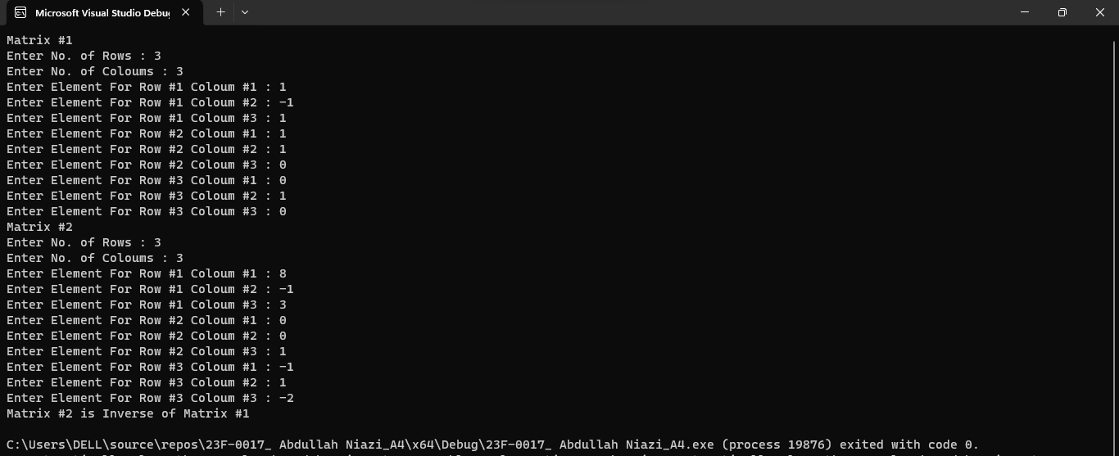

**Question#2**

**Code :**

#include<iostream>

using namespace std;

void eliminate_duplicates(int arr[],int & size) {

for (int i = 0; i < size; i++) {

for (int j = i + 1; j < size; j++) {

if (arr[i] == arr[j]) {

arr[j] = 0;

}

}

}

for (int i = 0; i < size; i++) {

for (int j = i + 1; j < size; j++) {

int temp = arr[i];

if (arr[j] > temp) {

arr[i] = arr[j];

arr[j] = temp;

}

}

}

for (int i = 0; i < size; i++) {

if (arr[i] == - 1) {

size = i;

break;

}

}

}

int main() {

const int maxsize = 100;

int arr[maxsize];

int size;

cout << "Enter Array size : "; cin >> size;

for (int i = 0; i < size; i++) {

cout << "Enter Element #" << i + 1 <<" : "; cin >> arr[i];

}

eliminate_duplicates(arr, size);

for (int i = 0; i < size; i++) {

cout << "Element #" << i + 1 << " : " << arr[i] << endl;

}

return 0;

}

**Output :**

**Question#3**

**Code :**

#include <iostream>

#include<cstring>

using namespace std;

void sortNames(char name[3][10]) {

int arr[3];

int flag = 0, flag1 = 0;

for (int i = 0; i < 3; i++) {

int sum = 0;

for (int j = 1; j <= strlen(name[i]); j++) {

int temp = static_cast<int>(name[i][j - 1]);

sum = sum + temp * j;

}

arr[i] = sum;

}

for (int i = 0; i < 3; i++) {

for (int j = i + 1; j < 3; j++) {

int temp = arr[i];

if (temp < arr[j])

flag = i;

flag1 = j;

temp = arr[j];

}

}

cout << name[flag] << " " << name[flag1] << " " << name[3 - flag - flag1] << endl;

}

int main() {

char name[3][10] = { "Saim","Abdullah","Huzaifa" };

sortNames(name);

return 0;

}

**Output :**

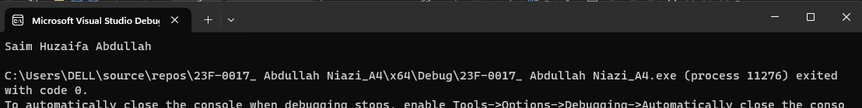

**Question#4**

**Code :**

#include <iostream>

#include<cstring>

using namespace std;

void longestWord(char arr[][10],int n) {

int max = 0, flag = 0;

max = strlen(arr[0]);

for (int i = 1; i < n; i++) {

if (max < strlen(arr[i])) {

max = strlen(arr[i]);

flag = i;

}

}

cout << "Largest Word Is : " << arr[flag] << endl;

cout << "Word Lenght Is : " << max << endl;

}

int main() {

int n;

const int size = 100;

char arr[size][10];

cout << "Enter No. of Words : "; cin >> n;

for (int i = 0; i < n; i++) {

cout << "Enter a Word : "; cin >> arr[i];

}

longestWord(arr,n);

return 0;

}

**Output :**

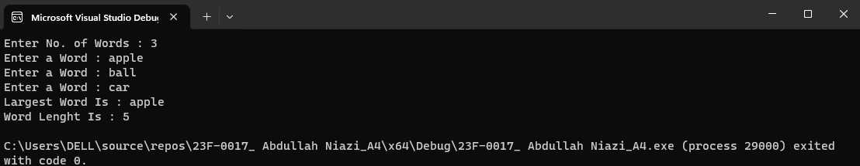

**Question#5**

**Code :**

#include<iostream>

using namespace std;

int g_c_d(int a,int b) {

int greatnum = 0, gcd = 1;

if (a >= 0 && b >= 0) {

if (a > b) {

greatnum = a;

}

else {

greatnum = b;

}

for (int i = 1; i <= greatnum; i++) {

if (a % i == 0 && b % i == 0) {

gcd = i;

}

}

}

else {

return 0;

}

return gcd;

}

int main() {

int num1, num2;

cout << "Enter Number #1 : "; cin >> num1;

cout << "Enter Number #2 : "; cin >> num2;

if (g_c_d(num1, num2) == 0) {

cout << "Invalid Input" << endl;

}

else {

cout <<"Greatest Common Divisor Is : " << g_c_d(num1, num2) << endl;

}

return 0;

}

**Output :**

**Question#6**

**Code :**

#include<iostream>

using namespace std;

void convertDouble(double &value) {

if (value >= 0) {

double factorial = 1;

for (int i = 1; i <= value; i++) {

factorial = factorial * i;

}

cout << "Factorial : " << factorial << endl;

}

if (value < 0) {

value = -value;

}

if (value == 0) {

value = 42;

}

cout << "Double Value : " << value << endl;

}

void convertint(int &value) {

if (value % 2 == 0) {

value = value * value * value;

}

else {

int sum = 0;

while(value > 0){

sum = sum + value % 10;

value = value / 10;

}

cout << "Sum Is : " << sum << endl;

}

if (value % 3 == 0) {

value = 100;

}

cout << "Integer Value : " << value << endl;

}

int main() {

double numD;

int numIn;

cout << "Enter Double Value : "; cin >> numD;

cout << "Enter Integer Value: "; cin >> numIn;

convertDouble(numD);

convertint(numIn);

return 0;

}

**Output :**

**Question#7**

**Code :**

#include<iostream>

#include<fstream>

using namespace std;

int main() {

const int size = 20;

float arr[20];

ifstream inputfile;

ofstream outputfile;

inputfile.open("Input.txt");

if (inputfile.is_open()) {

for (int i = 0; i < size; i++) {

inputfile >> arr[i];

}

}

inputfile.close();

cout << "Unsorted Array" << endl;

for (int i = 0; i < size; i++) {

cout <<"Index : "<< i << " Element : " << arr[i] << endl;

}

for (int i = 0; i < size; i++) {

for (int j = i + 1; j < size; j++) {

float temp = arr[i];

if (temp > arr[j]) {

arr[i] = arr[j];

arr[j] = temp;

}

}

}

cout << "Sorted Array" << endl;

for (int i = 0; i < size; i++) {

cout << "Index : " << i << " Element : " << arr[i] << endl;

}

outputfile.open("Output.txt");

for (int i = 0; i < size; i++) {

if (outputfile.is_open()) {

outputfile << arr[i] << endl;

}

}

outputfile.close();

return 0;

}

**Output :**

**Input File :**

**Output File :**

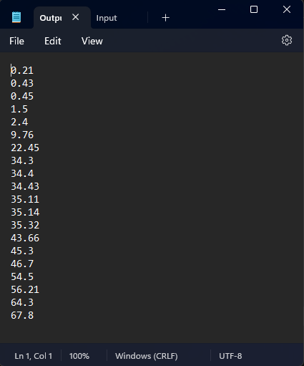

**Question#8**

**Code :**

#include<iostream>

#include<fstream>

#include<cstring>;

using namespace std;

int main() {

char name[10], age[5], address[15], income[10];

for (int i = 0; i < 5; i++) {

cout << "Employee #" << i + 1 << endl;

cout << "Enter Name : "; cin.getline(name, 10);

cout << "Enter Age : "; cin.getline(age, 5);

cout << "Enter Address : "; cin.getline(address, 15);

cout << "Enter Income : "; cin.getline(income, 10);

for (int i = 0; i < strlen(name); i++) {

name[i] = name[i] + 1;

}

for (int i = 0; i < strlen(address); i++) {

address[i] = address[i] + 1;

}

for (int i = 0; i < strlen(age); i++) {

age[i] = age[i] + 1;

}

for (int i = 0; i < strlen(income); i++) {

income[i] = income[i] + 1;

}

ofstream myfile;

myfile.open("employee.txt", ios :: app);

myfile << name << endl;

myfile << age << endl;

myfile << address << endl;

myfile << income << endl;

myfile.close();

}

ifstream myfile1;

myfile1.open("employee.txt");

for (int i = 0; i < 20; i++) {

char arr[15];

myfile1.getline(arr,15);

for (int j = 0; j < strlen(arr); j++) {

arr[j] = arr[j] - 1;

cout << arr[j];

}

cout << endl;

}

myfile1.close();

return 0;

}

**Txt File :**

